PROFESSIONAL PROJECT DEVELOPMENT DOCUMENT

AI-Based Financial Transaction Analysis System Using OCR and BERT

Name | Abhineet Bhattacharya
UID / Roll | TNUR20241053002
Department | Computer Science & Engineering (AI & ML)
Semester | 5th
University | The Neotia University
Internship Company | Kognitive Technologies
Internship Duration | 15th June 2026 to 15th July 2026
Submitted To | Mr. Bikash Bej

Table of Contents
Table of Contents 1
1. Abstract 1
2. Introduction 1
2.1 Objectives 1
2.2 Advantages 1
3. Methodology 1
4. Technical Components 1
4.1 Project Architecture 1
4.2 Data Schema 1
4.3 Model Training 1
4.4 Testing 1
4.5 Prediction Process 1
5. Visualization 1
6. System Architecture 1
7. Final Outcome (Results & Discussion) 1
7.1 Results 1
7.2 Future Scope 1

1. Abstract
The AI-Based Loan Verification System is a web application developed to automate the verification of loan applicants by analyzing salary slips and bank statements using Artificial Intelligence and Optical Character Recognition (OCR). The primary objective of the project is to reduce manual effort, improve accuracy, and speed up the loan approval process.
The system allows users to upload salary slips or bank statements through a secure web interface. OCR techniques are used to extract textual information from the uploaded documents. The extracted information is then analyzed using Artificial Intelligence techniques to identify salary details, classify bank transactions, generate financial summaries, and determine loan eligibility based on predefined financial criteria. The application is developed using the Flask framework and integrates EasyOCR, Tesseract OCR, pdfplumber, and Transformer-based Natural Language Processing models. Financial information is presented visually through graphs and charts, allowing users and financial institutions to better understand spending patterns and income distribution. This project demonstrates how Artificial Intelligence can improve banking services by reducing document verification time, minimizing human errors, and providing intelligent decision support.

2. Introduction
Financial institutions and individuals handle numerous bank statements every month. Manual analysis of these statements is time-consuming and error-prone. The objective of this project is to automate financial transaction analysis using Artificial Intelligence and Machine Learning techniques.

2.1 Objectives
- Extract transaction details from PDF bank statements.
- Automatically classify transactions using BERT.
- Display categorized transactions.
- Generate graphical reports.
- Provide a secure login interface.
- Improve speed and accuracy compared to manual analysis.

2.2 Advantages
- Saves time
- Reduces human error
- Easy to use
- Automatic categorization
- Better financial insights

3. Methodology
The project follows a structured seven-step workflow, illustrated below:

Step 1: User Login
Users log into the system using a secure authentication page.
↓
Step 2: Upload Bank Statement or payslip
The user uploads a PDF bank statement.
↓
Step 3: OCR / Text Extraction
The system extracts text from the uploaded document.
↓
Step 4: Data Preprocessing
Remove unwanted characters • Clean extracted text • Split into transactions
↓
Step 5: Transaction Classification
Cleaned transactions are passed into the trained BERT model,
which predicts categories such as Food, Shopping, Salary,
Travel, Bills, Entertainment, and Others.
↓
Step 6: Data Visualization
Generate Pie Chart, Bar Chart, and Transaction Table.
↓
Step 7: Financial Report
Display categorized transactions and analysis.

4. Technical Components
Component | Technology Used
Programming Language | Python 3.13
Frontend | HTML, CSS
Backend | Python
Machine Learning Model | BERT
OCR Library | PaddleOCR / Tesseract OCR
Data Processing Libraries | Pandas, NumPy, Regular Expressions (re)
Visualization Library | Matplotlib
PDF Processing | pdfplumber
Other Libraries | transformers, torch, scikit-learn

4.1 Project Architecture
User
↓
Login Page
↓
Upload Bank Statement
↓
OCR Engine
↓
Text Extraction
↓
Data Cleaning
↓
BERT Model
↓
Transaction Classification
↓
Database / Memory
↓
Dashboard
↓
Pie Chart + Bar Chart + Transaction Table

4.2 Data Schema
Input: Bank Statement PDF
Extracted Fields:
- Date
- Description
- Amount
- Debit
- Credit
- Balance
Output Fields:
- Transaction
- Category
- Amount
- Prediction Confidence

4.3 Model Training
Dataset: Bank transaction dataset containing Transaction Description and Category Label
Preprocessing:
- Lowercase conversion
- Remove special characters
- Tokenization
- Padding
- Attention masks

Training Parameter | Value
Model | BERT-base-uncased
Optimizer | AdamW
Loss Function | CrossEntropyLoss
Epochs | 3 – 5
Batch Size | 16
Learning Rate | 2e-5

4.4 Testing
The trained model predicts transaction categories for unseen bank statements. Sample predictions are shown below:
Transaction | Predicted Category
Amazon Purchase | Shopping
Swiggy | Food
Salary Credit | Salary
Uber Ride | Travel

4.5 Prediction Process
Input Transaction
↓
Tokenizer
↓
BERT Encoder
↓
Classification Layer
↓
Predicted Category

5. Visualization
The following screenshots illustrate the application's user interface and outputs. (Insert actual screenshots of the application in place of the placeholders below.)
Screenshot 1: Login Page
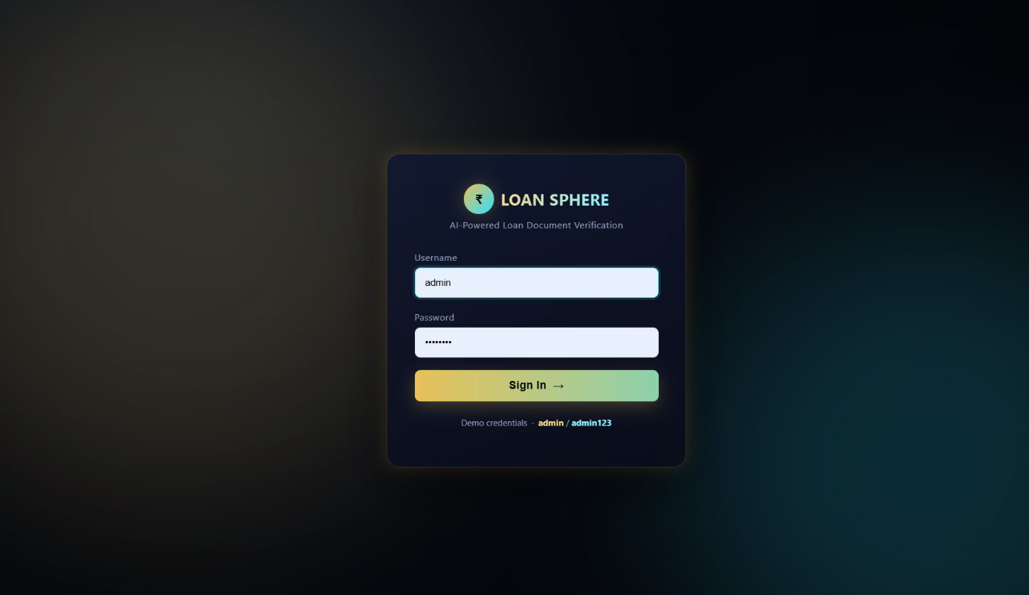
Description:
- Username field
- Password field
- Login button

Screenshot 2: Upload Page
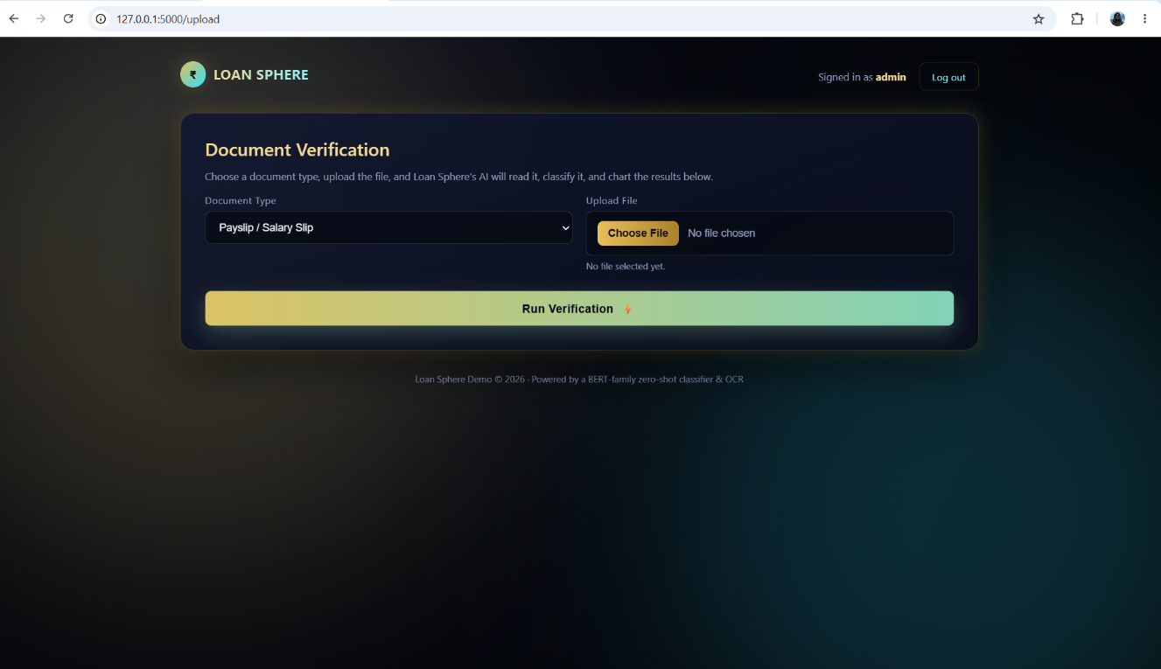
Description:
- PDF upload button
- Submit button

Screenshot 3: Payslip
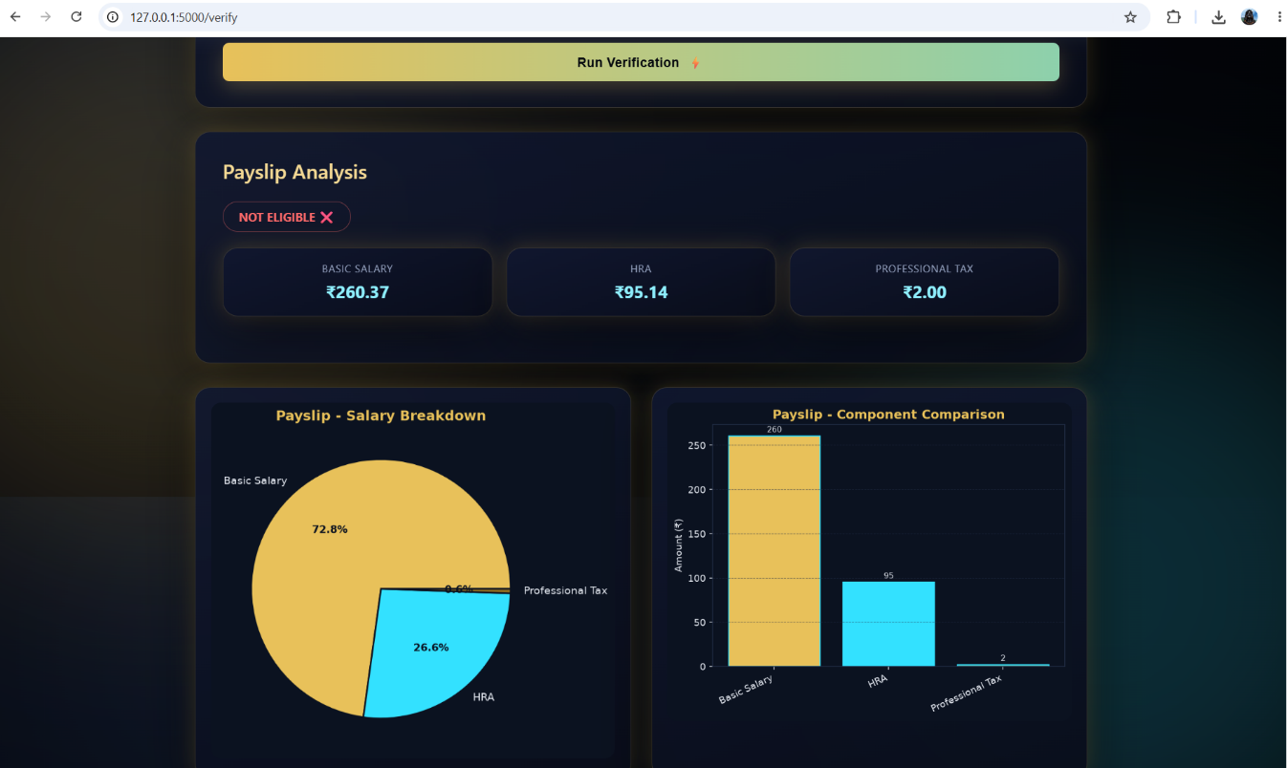
Description:
- Shows percentage distribution of transaction categories.

Screenshot 4: Bank Statement
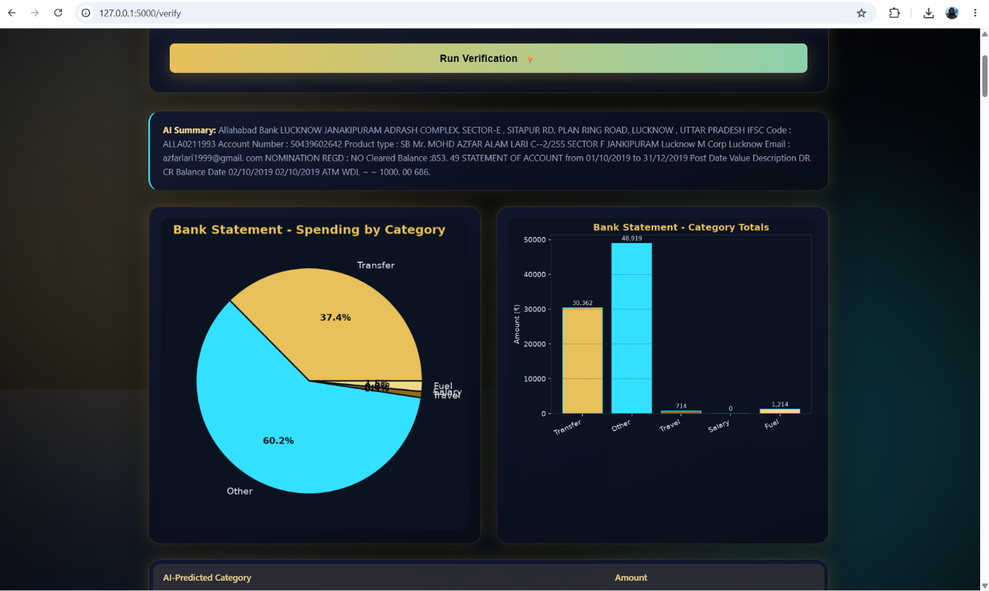
Description:
- Displays total transaction amount for each category.

6. System Architecture
User
↓
Login Module
↓
Upload Bank Statement
↓
OCR Text Extraction
↓
Data Preprocessing
↓
BERT Classification
↓
Visualization (Pie Chart, Bar Chart)
↓
Financial Report

7. Final Outcome (Results & Discussion)
The developed AI-Based Loan Verification System successfully automates the verification of loan-related financial documents by extracting, analyzing, and visualizing data from salary slips and bank statements. The application combines Optical Character Recognition (OCR), Artificial Intelligence, and data visualization techniques to reduce manual verification efforts and improve decision-making.
The system accurately extracts financial information from uploaded documents using EasyOCR, Tesseract OCR, and pdfplumber. The extracted text is processed using an AI-based transaction classification model that categorizes bank transactions into meaningful financial categories. Salary information such as Basic Salary, House Rent Allowance (HRA), and Professional Tax is automatically identified to determine loan eligibility.
The application provides an interactive web interface developed using the Flask framework, where users can upload documents, view extracted financial information, analyze categorized transactions, and visualize spending patterns through pie charts. The AI-generated financial summary further assists users in understanding their financial profile quickly.
The proposed system significantly reduces document verification time while improving the overall efficiency and transparency of the loan approval process.

7.1 Results
- Automated extraction of salary slip information.
- Automated extraction of bank statement transactions.
- OCR-based document digitization with high accuracy.
- AI-powered classification of financial transactions.
- Automatic salary analysis and loan eligibility verification.
- Interactive dashboard with graphical visualizations.
- Pie chart generation for expense analysis.
- AI-generated financial document summary.
- Faster processing and improved accuracy.
- User-friendly Flask-based web application.

7.2 Future Scope
The AI-Based Loan Verification System can be enhanced with several advanced features in the future. Integration with Aadhaar, PAN, and credit score verification APIs can make the verification process more reliable. The system can be deployed on cloud platforms to support multiple users simultaneously and improve scalability. Advanced AI models such as FinBERT can be incorporated for more accurate financial document analysis and fraud detection. A mobile application can also be developed to allow users to upload documents and track loan applications from anywhere. Additionally, real-time banking API integration and blockchain-based document verification can further improve security, transparency, and efficiency in the loan approval process.

